Test Report

For

Natural Language Understanding Module

Version 1.5

Prepared by the Tongue Twisters Project Team:

Andrew Rohn, Eskedar Endashw, Firehiwot Chari, Joseph Kalfus, Leelakrishnan Subramaniam, Malik Webster & Obinna Okonkwo.

November 5th, 2021

Date | Version | Description | Author
October 24, 2021 | 1.0 | Initial Release Template | Firehiwot Chari
October 31, 2021 | 1.1 | Updated Introduction Section | Firehiwot Chari
November 3, 2021 | 1.2 | Added step by step guides | Malik Webster
November 4, 2021 | 1.3 | Added application page | Obinna Okonkwo
November 5, 2021 | 1.4 | Added troubleshooting steps | Andrew Rohn
November 5, 2021 | 1.5 | Fixed formatting and image captions | Joseph Kalfus

Table of Contents
1. Introduction 4
1.1 Purpose 4
1.2 Overview 4
1.3 Abbreviations/Acronyms/Definition 4
2. Hardware and Software Specification 4
3. Application Page 5
3.1 Application Calendar Page 5
3.2 Application Checklist Page 6
3.3 User Help Page 8
3.4 Application Menu Page 10
3.5 Application Notes Page 12
3.6 Application Notification Page 14
3.7 User Settings Page 16
3.8 User Trigger Page 18
4. Launching the application 20
4.1 Memory Magic Splash 20
4.2 Onboarding Select Language Screen 21
4.3 Onboarding Permission Screen 23
4.4 Onboarding Introduction Screen 27
4.5 Onboarding Home Screen 28
4.6 Home Screen 28
5. Step-by-Step Guides 30
5.1 Start a Conversation with the NLU 30
5.2 Navigate to the Notes Screen 32
5.3 Create A Note 34
5.4 Create an Event 36
5.5 Create a Recurring Event 39
5.6 Ask the NLU Questions 42
6. Troubleshooting 44
6.1 Microphone is Not Working 44
6.2 Receiving “I’m sorry, but I don’t understand.” 44

Introduction

Purpose
The purpose of this User Guide document is to describe the functional and operational procedure of the Memory Magic application. The goal of this user guide document is to help non-technical people to operate the app properly and to solve problems without expert assistance.

Overview
Short Term Memory (STM) is how the brain stores small amounts of information it is just taken in for a relatively short time (usually up to 30 second). When people have a short-time memory loss, they forget things they heard, saw, or did recently. Forgetting things could be normal when people get older, but it is also a sign of short-term memory loss. People with STM loss ask the same question repeatedly, forgetting recent events.
There are many causes for the short-term memory loss. Some of the potential causes are aging, Alzheimer, brain tumors, head injuries, substance use disorder, stress, illness, or any conditions that damage brain tissue, inadequate sleep, anxiety medication and anti-seizure drugs.
To assist people with STM, the Memory Magic App has been developed, and the Natural Language Understanding (NLU) module has been incorporated to make the life of people with STM better.

Abbreviations/Acronyms/Definition
Table 1 shows acronyms/abbreviations and their definitions:
Table 1
Acronyms, Abbreviations, and Definitions
Acronyms and Abbreviations | Definitions
iOS | iPhone Operating System
NLU | Natural Language Understanding
STM | Short-Term Memory

Hardware and Software Specification
The Memory Magic Application is designed to run on smartphones, no hardware interface needed. The mobile application can be installed on the android and iOS platform. The application is deigned to run on Android 8.0, iOS 10 and up.

Application Page

Application Calendar Page
The application calendar page will open when the user states “I want to see my events”. This command will instruct the NLU Module to direct the user to the calendar screen. While on this page, the user will be able to view different events that have be placed on the calendar. While on this page, events may be selected and removed as the user sees fit.
Figure 1
Events Request
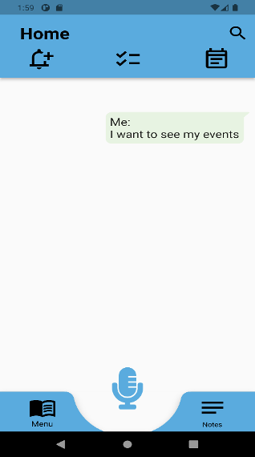

Figure 2
Calendar Display
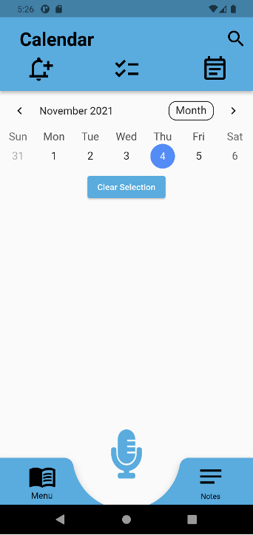

Application Checklist Page
The application checklist page will open when the user states “show me my checklist”. This command will instruct the NLU Module to direct the user to the checklist list page. This screen will display the checklist items save under the selected date.

Figure 3
Checklist Request
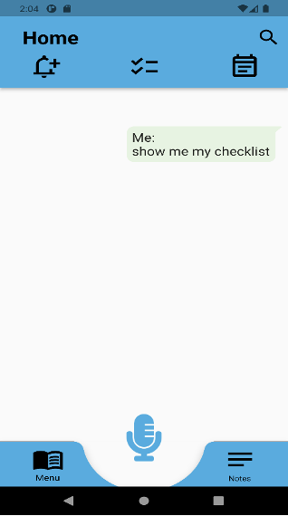

Figure 4
Checklist Response

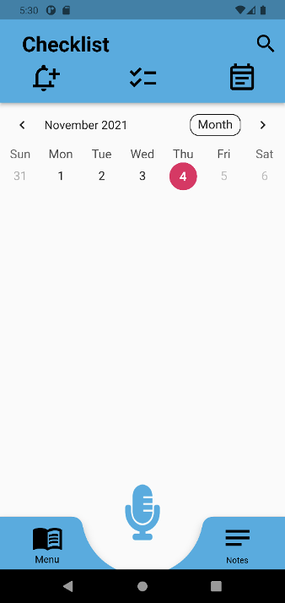

User Help Page
The User Help page will open when the user states “I need help with the app”. This command will instruct the NLU Module to direct the user to the user help page. The User will have the option of selecting one of the 4 buttons shown below on this screen.

Figure 5
Help Request

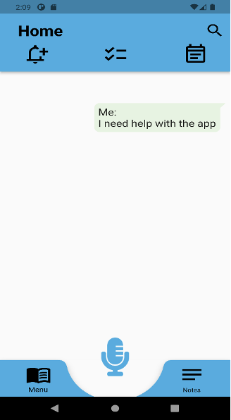

Figure 6
Help Response

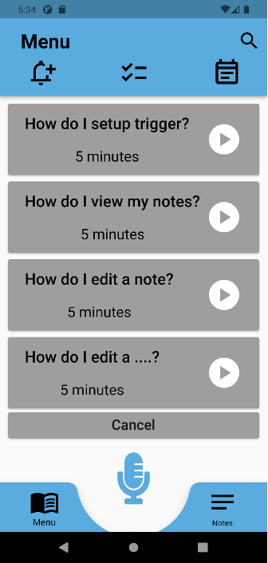

Application Menu Page
The Application Menu page will open when the user states “take me to the home page”. This command will allow the user to select from 4 distinct options: “Sync to Cloud”, “Trigger”, “Settings”, and “Help”. The selection of any of the options will direct the user to the selected screen.

Figure 7
App Navigation Request

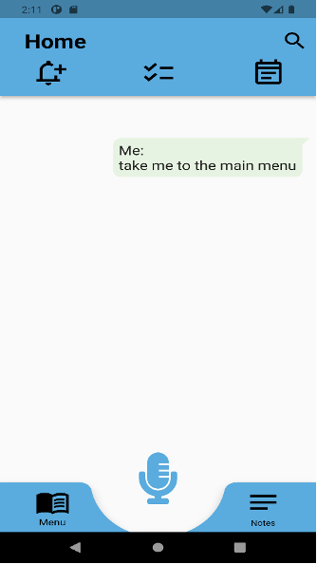

Figure 8
App Navigation Response

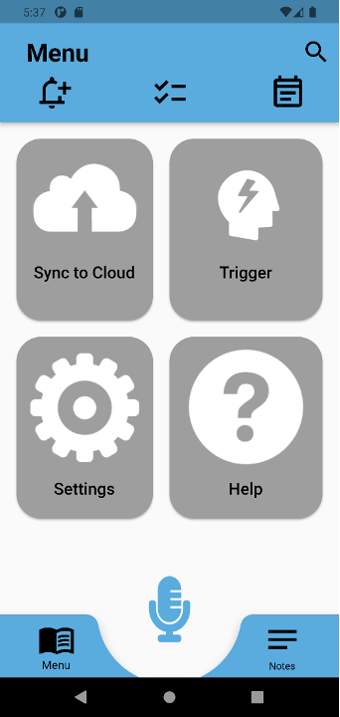

Application Notes Page
The Application Notes page will open when the user states “I want to make a note”. This command will direct the user to the Application Notes page, where any notes previously created and saved will be showcased to the user. When the user clicks on the “+” icon, they will be directed to another page for the creation of a note.

Figure 9
A Note Creation

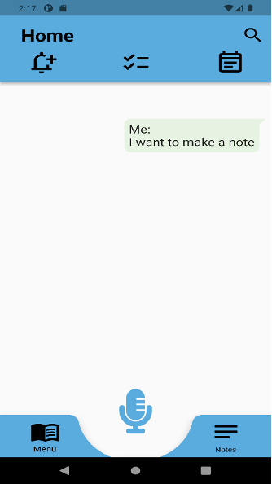

Figure 10
A Note Being Created

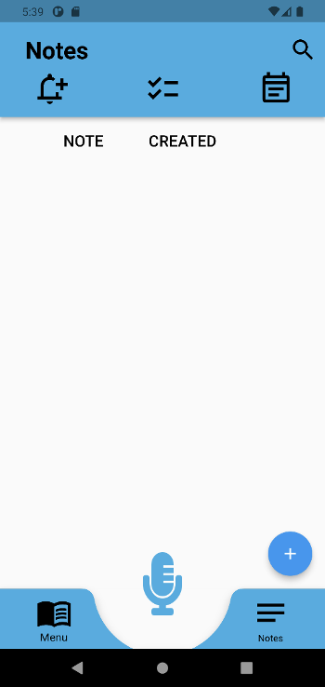

Application Notification Page
The Application Notification page will open when the user states “I want to check my notifications”. The command will direct the user to a page where they will see the notification settings options open to modifying as the user sees fit.

Figure 11
A Notification Request

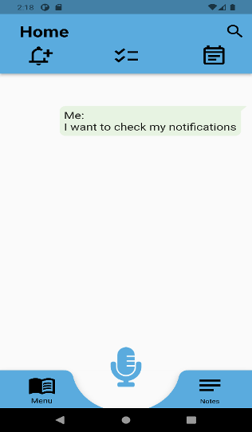

Figure 12
A Notification Response

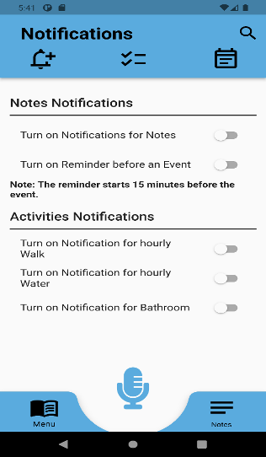

User Settings Page
The User Settings page will open when the user states “I need to adjust my settings”. This command will direct the user to the User Settings page, where the settings for the user will appear. The page will allow the user to modify the font size, language and theme used within the application.

Figure 13
An Application Change Request
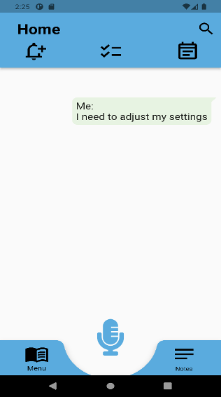

Figure 14
An Application Change Request Response
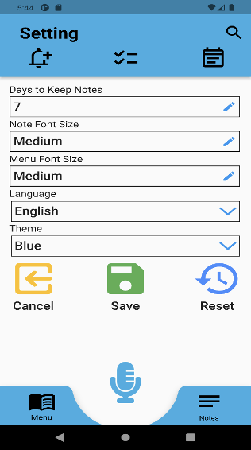

User Trigger Page
The User Trigger page will open when the user states “I want to change my trigger phrase”. This command will direct the user to the User Trigger page, where the guide for the creation of a new trigger phase will appear for the user. The page holds a “save” icon for the user to complete the task and also a “cancel” icon if the user chooses to cancel the entry made.

Figure 15
Changing the Trigger Phrase Request

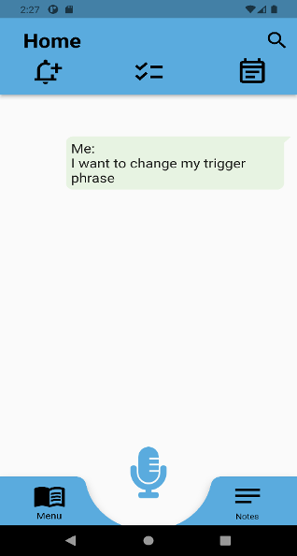

Figure 16
Changing the Trigger Phrase Response
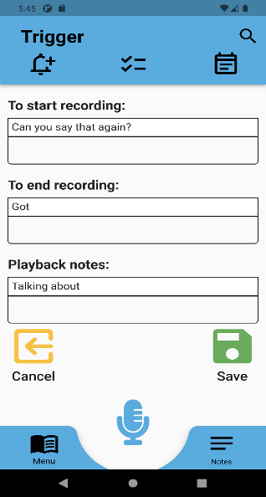

Launching the application

Memory Magic Splash
The Memory Magic splash screen, as shown below, is a 6-second animation of the Memory Magic logo that appears when the application is first open. It will lead to the screens that will assist the user with onboarding.

Figure 17
Memory Magic Splash Screen
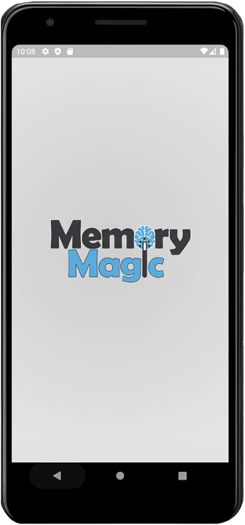


Onboarding Select Language Screen

The first screen after the splash introduction is the select language screen which begins the onboarding process. This allows the user to select the preferred language by clicking the dropdown button, as shown below. After selecting the language, the user can proceed to the next screen by selecting the next button.

Figure 18
Selecting the Primary Language for Application
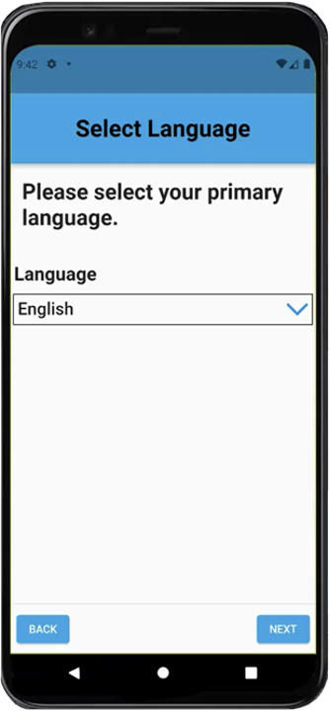

When the user clicks the dropdown button on the select language screen, the user can change the default language, as shown below. These languages are English, Spanish (Castilian), Portuguese, Chinese, and Arabic; English is the default language.

Figure 19
Displaying a Different Language for Application
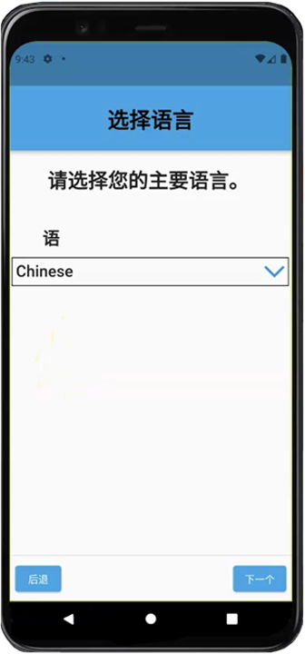

When the user selects a different language on the select language screen, the text will be translated on the screen, as shown below. Below, the language has been changed to Chinese which will be reflected throughout the entire application.


Onboarding Permission Screen

If the user does not allow the application to access the microphone, the user will see the warning message “features will be limited without allowing access to your microphone”, as shown below, and the user can press the next button and proceed with restrictions.

Figure 20
The Language Options of Application
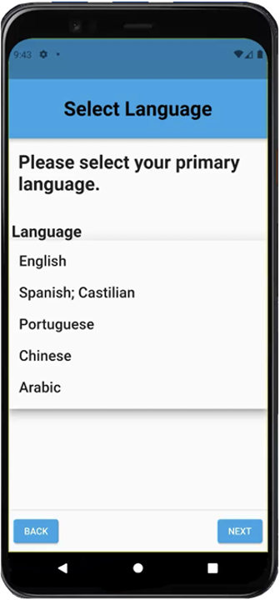

If the user allows the application to access the microphone, the “features will be limited without allowing access to your microphone” message will disappear, as shown below, and the user can press the next button and proceed without restrictions.

Figure 21
Requesting Access to Smartphone Microphone
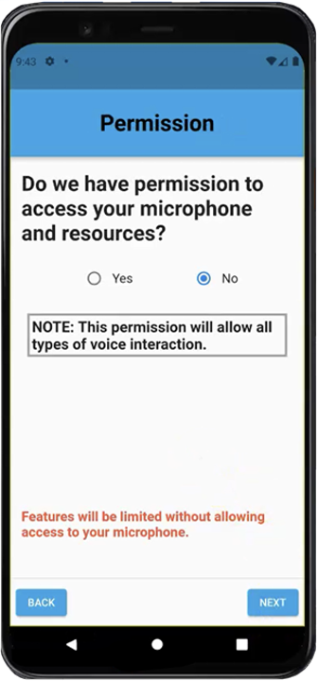

Figure 22
Requesting Access to Smartphone Microphone

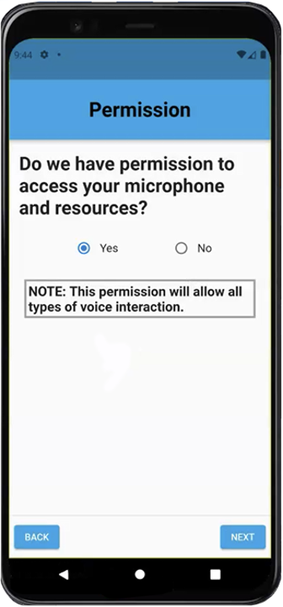
When the user selects “YES,” and clicks the next button to proceed to the next screen, a window will appear, as shown below, asking the user to allow/deny access to record audio. The user can either allow or deny.

Figure 23
Asking for Audio Recording
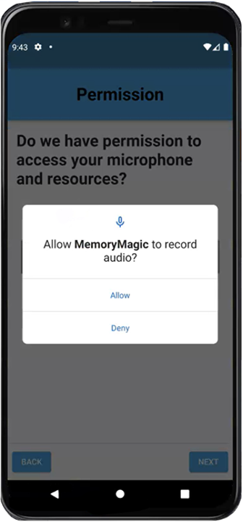

Onboarding Introduction Screen
The onboarding introduction screen has several videos that will give the user a comprehensive overview/walkthrough of how to use the application, as shown below.

Figure 24
Application Home Screen
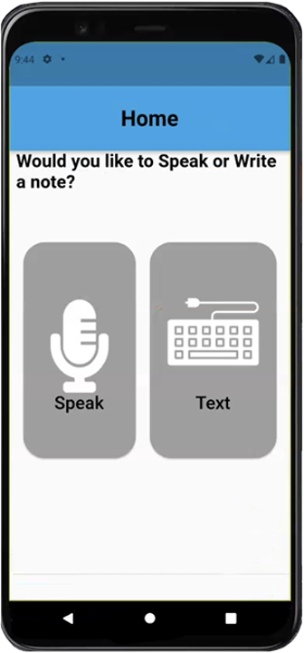

Onboarding Home Screen
The last onboarding screen is the onboarding home screen, as shown below. This screen asks the user’s preference to create notes: speaking into the microphone or texting the note with the keypad. If the user did not allow the application access to the device’s microphone, the speak option will not work.

Home Screen
Onboarding is complete and the figure shown below, shows the official home screen. There is a microphone at the bottom of the screen that the user can press to record a note. The top navigation icons (from left to right) are the notifications screen, checklist, and calendar. The bottom navigation (from left to right) is the access the menu and notes screens.

Figure 25
Application Home Screen
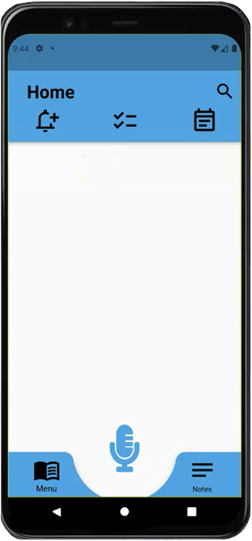

Step-by-Step Guides
The purpose of this section is to provide a detailed overview of how to use the NLU application.

Start a Conversation with the NLU
Figure 26
Showcasing the Application Microphone
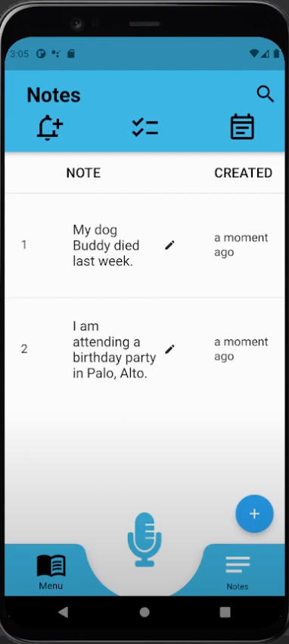
Upon pressing the microphone button, the NLU app is triggered. As the user, speak into the microphone and the NLU app will automatically detect the languages spoken and process your speech.

Figure 27
Simple request and response
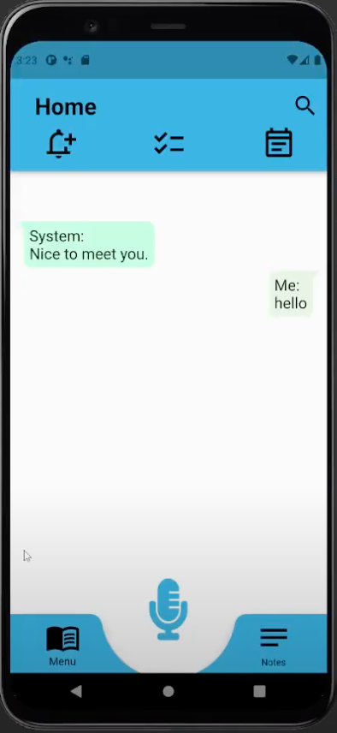
This screenshot is an example of a response that can be given by the NLU app. The app moves to this chat screen once a dialog has been started. You can repeat step 1 as needed to continue the conversation.

Figure 28
Showcasing various questions and answers
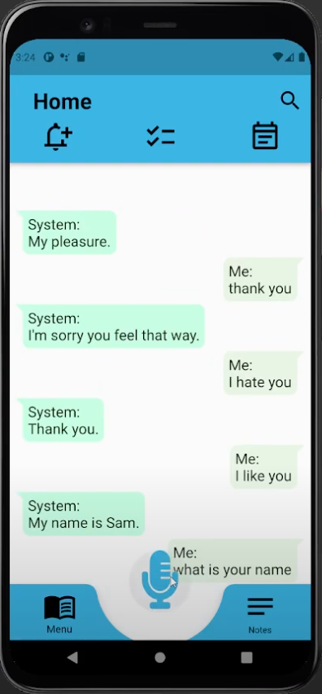
Note: This screenshot is an extension of the conversation initiated in the last screenshot.

Navigate to the Notes Screen
At any point, you can tell the NLU that you want to see another part of the application, such as your notes or calendar. To do this, click the microphone again as you did in step 1 and tell the application where you want to go. The below screenshots show what happens when you tell the NLU that you want to see your notes.

Figure 29
Requesting to see notes
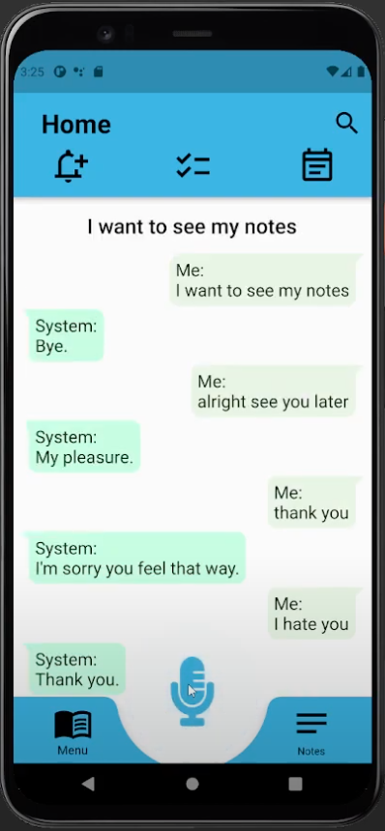

Figure 30
Displaying Notes Screen
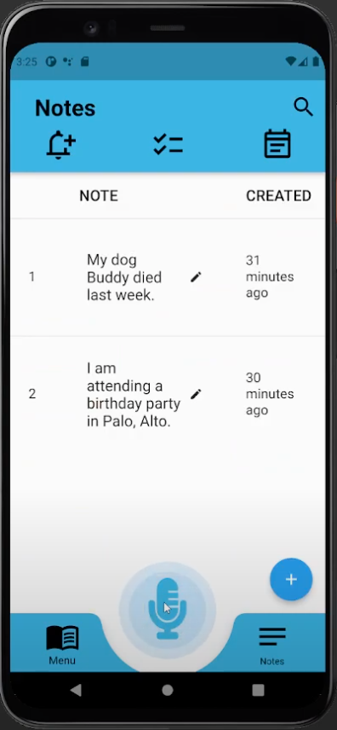
After speaking the command, the app takes the user to the Notes screen.

Create A Note
The NLU app can do more than respond to simple tasks. For instance, the user might want to create a note. Press the microphone button and tell the application the content you want to go into the note (i.e., tell the NLU “I have a son named David”).

Figure 31
Creating a Note Request, Response, Confirmation
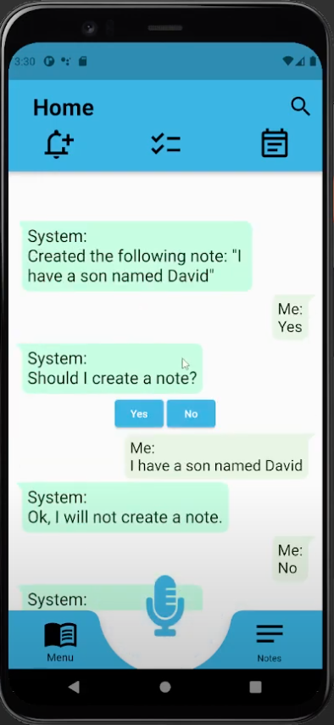
After speaking the contents of the note, the system will ask “Should I create a note?”. If you say yes, the system will then generate the note.

Figure 32
Displaying Notes
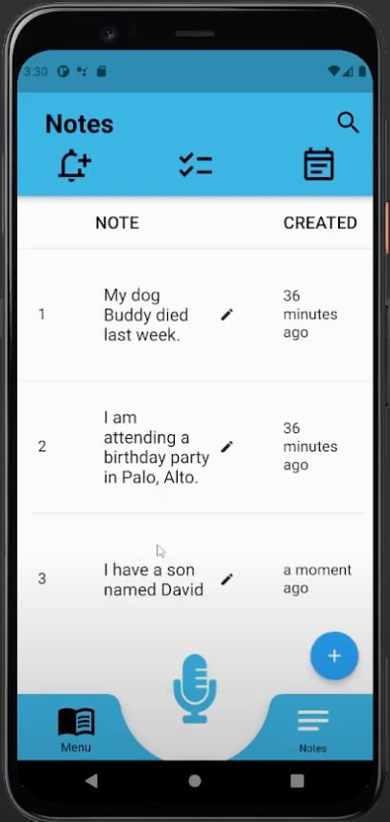
As shown in the above screenshot, a new note was added to the bottom of the list showing the speech the user just input moments before.

Create an Event
Notes that have a date and a time become events. This section will walk you through how to create an event with speech. First, tell the application that an event is coming. The system will ask “On what date?” Say the date, then the NLU will prompt you for the time.

Figure 33
Application Request, Response with Dates
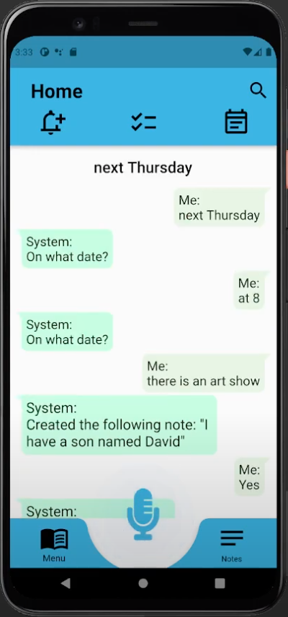

Figure 34
Confirming AM or PM
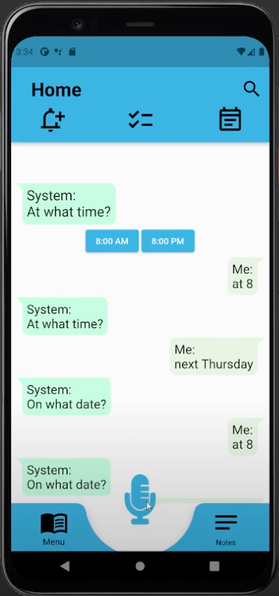
After specifying the time, the NLU will ask if it should create a note. If you say yes, the app will redirect you to the new note that is created that has the event details.

Figure 35
Viewing Event Details
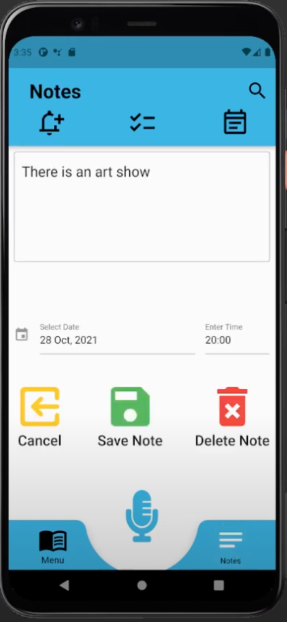

Create a Recurring Event
Similar to creating an event in Step 4, you can create a recurring event. For instance, let’s say that you tell the NLU that once a week, you have a business meeting on Friday at 4 pm. The system will ask to create a note of that and if you say yes, the recurring event will be saved as a note.

Figure 36
Setting Up Recurring Events
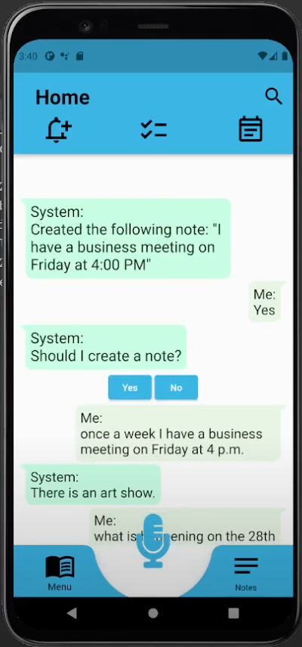

Figure 37
Displaying a Recurring Event within Notes
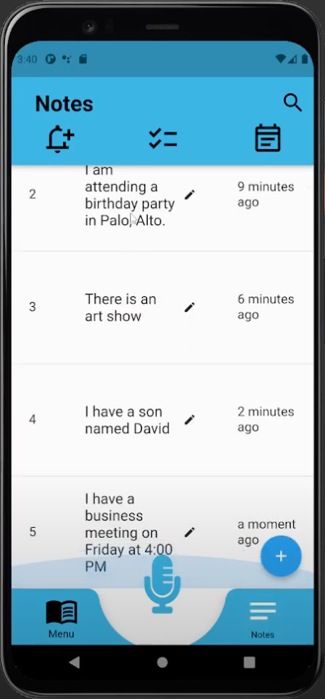
As shown in the above screenshot, the note for the recurring event has been created.

Figure 38
Displaying the Checklist Screen
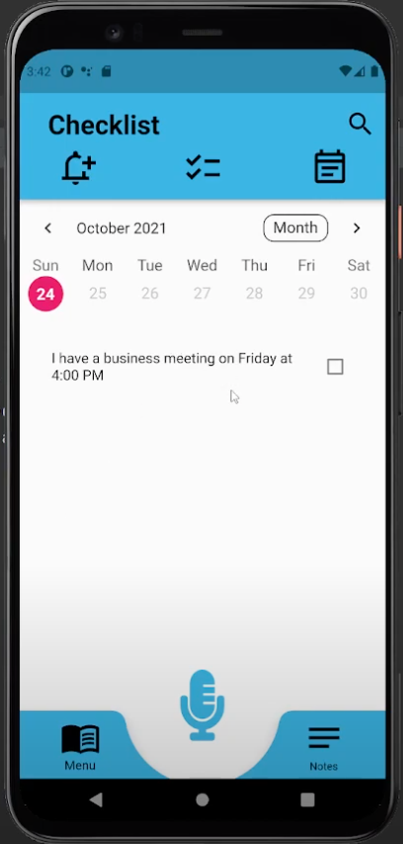
Recurring events also show up on the Checklist screen.

Ask the NLU Questions
Now that you have created a few notes, you can start asking the NLU questions based on the notes you’ve entered. For example, you have a note stating “I have a son named David”. If you ask the NLU what your son’s name is, the system should return “David” as shown in the screenshot below.

Figure 39
Asking NLU Various Questions (to query from Notes)
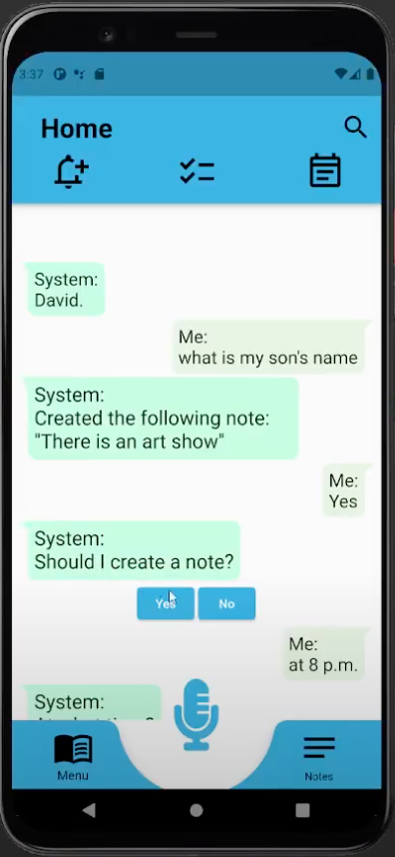

Troubleshooting
This section of the User Guide will provide troubleshooting solutions for common issues that the user may experience when attempting to interact with the NLU Module while using the Memory Magic App. Separates steps are provided for both the Android and iOS versions of the application. It is important to note however, the user does not directly interface with the NLU Module and instead interfaces with the Memory Magic Application, which in turns interfaces with the NLU Module. Therefore, troubleshooting solutions are limited to what the user can do within the Memory Magic Application and on their device.

Microphone is Not Working
The NLU Module is only interfaced by the Memory Magic Application after the user has spoken into the microphone. Once a voice has been recorded, the recording is transcribed into text. This text is sent to the NLU Module to determine its intent and to determine what functionality would best accommodate the user. Therefore, if the microphone is not working, the user will be unable to interface with the NLU Module.
To enable the microphone on an Android device:
- Tap the Settings icon .
- Scroll down and tap through following menu options: Apps Google Play Services Permissions.
- Tap the slider next to “Microphone” so that it is in the On position .
To enable the microphone on an iOS device:
- Tap the Settings icon .
- Scroll down and find the Memory Magic Application option.
- Tap the Memory Magic Application option.
- Tap the slider next to “Microphone” so that it is in the On position .

Receiving “I’m sorry, but I don’t understand.”
Once the microphone is enabled and functioning properly, the user should be able to speak into the microphone and their voice should be transcribed into text. This text will be displayed on the screen as the user is speaking. If the user says something and the Memory Magic Application replies with “I’m sorry, but I don’t understand.”, this means that the NLU Module is unable to determine what the user is saying. If this happens, please try the following suggestions:
- Speak loudly and clearly into the microphone
- Reword your speech to be more concise
- Check that the language setting for the Memory Magic Application matches the language you are speaking
If the user has done all the above and the Memory Magic Application is still replying with “I’m sorry, but I don’t understand”, the most likely problem is that the user is not connected to the internet. The NLU Module requires an internet connection to function.
To connect to the internet on an Android device:
- Tap the Settings icon .
- Scroll down and tap through following menu options: Connections Wi-Fi.
- Tap the slider so that it is in the On position . Your device will automatically search for available Wi-Fi networks.
- If you want to connect to a different Wi-Fi network, find the Wi-Fi network listed under “Available networks” and tap it to connect.
- Enter in the security password if it is required.
To connect to the internet on an iOS device:
- Tap the Settings icon .
- Scroll down and find the Wi-Fi option.
- Tap the slider next to “Wi-Fi” so that it is in the On position . Your device will automatically search for available Wi-Fi networks.
- If you want to connect to a different Wi-Fi network, find the Wi-Fi network listed under “MY NETWORKS” and tap it to connect.
- Enter in the security password if it is required.

